**TOT 4Bet Range** (FourBet) **TOT Fold to 4Bet** (Foldvs4Bet)

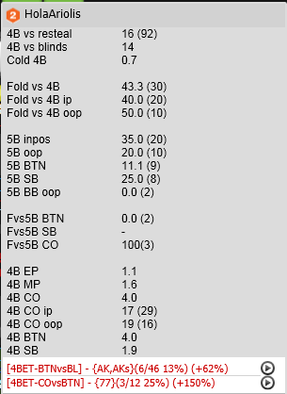 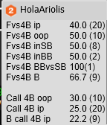

**Flop Fold to CB - 3BetPot** (FvsCB3B)

